|  |  |
| --- | --- |
| *school-learn-study-hat-graduate-512.png* | ***Study*** |

Read session 11.1, 11.2, 11.3, 11.4, 11.5, 11.6, 11.8, 11.9, 11.12 of the following book:

<http://www.ict.ru.ac.za/Resources/cspw/thinkcspy3/thinkcspy3.pdf>

And then answer the following questions:

* What is nested list?
* Can a list store both integers and strings in it?

**[!Important]**

* Read about remove() function and write an example using it
* Read about pop() function and write an example using it

Reference: <https://docs.python.org/3.5/tutorial/datastructures.html>

|  |  |
| --- | --- |
| *http://www.bestappsforkids.com/wp-content/uploads/2012/04/save-turtle.png* | ***Turtle exercises*** |

**Part A:**

Drawing the following shape:

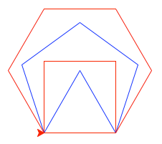

**Part B:**

Given the following list: colors = ['red', 'blue', 'brown', 'yellow', 'grey']

Use turtle to draw the following shapes:

|  |  |
| --- | --- |
|  | 2. |
|  |  |

Hint:

Google:

“turtle stroke color”

“turtle fill color”

|  |  |
| --- | --- |
| *6iporAnbT.jpg* | ***Serious exercises*** |

1. Finish CRUD exercise in class, simulate a clothes shop

Welcome to our shop, what do you want (C, R, U, D)? R

Our items: T-Shirt, Sweater

Welcome to our shop, what do you want (C, R, U, D)? C

Enter new item: Jeans

Our items: T-Shirt, Sweater, Jeans

Welcome to our shop, what do you want (C, R, U, D)? U

Update position? 2

New item? Skirt

Our items: T-Shirt, Skirt, Jeans

Welcome to our shop, what do you want (C, R, U, D)? D

Delete position? 3

Our items: T-Shirt, Skirt

Handle the exceptions (upper, lower case, index out of range) yourself

1. You are a shepherd who owns a flock of sheep

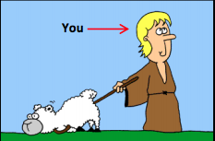

Each of your sheep of your flock has different size:

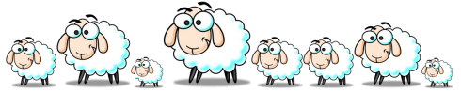

2.1 Create a list to represent the sizes of your flock, using list, and print all of your flock size, expected screen output:

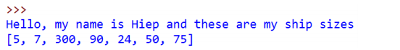

2.2. At the end of each month, you have to choose one and only one sheep to shear and thus you want to choose the biggest one to maximize your profit. Write a program to search for the biggest sheep in your list:

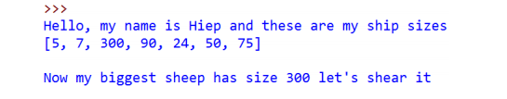

2.3. When your biggest sheer, its size will return to the default size, which is 8.

Print out your ship size after shearing the biggest one:

Hint: Google “Python List index function”

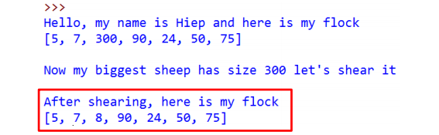

2.4 In the following month, EVERY sheep in your flock grow, they have their size increased by 50. Print them out

*Ask TA if you need help*

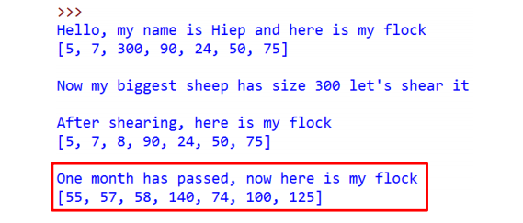

2.5. Let do this for 4 months (or as long as you want):

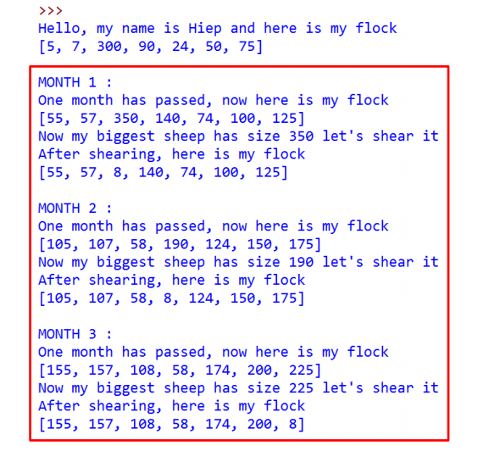

2.6 After day by day shearing sheep, you became bored. You want to sell your flock to travel the world. In order to have fair trade, you must now calculate the total size of your sheep and then the expected money you can get from your flock before going to the market. Write a program to calculate the total size of your sheep as well as the money you would have. Expected screen output:

